**Practical 4:**

**Aim:**

1. **Simulation of Apriori algorithm using Weka tool.**
2. **Implement the Apriori algorithm for frequent itemset mining for a given data set.**

**1 2**

**1 3 4**

**2 5 7**

**1 2 3**

**2 3 5 6**

**Solution a:**

**Using weather.nominal.arff as dataset**

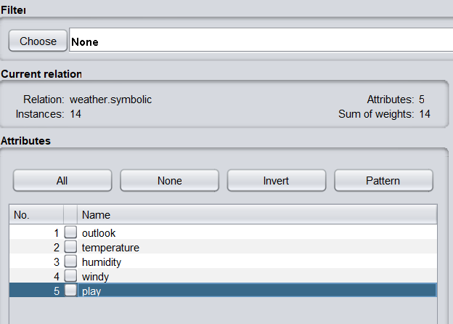

**Selecting apriori algorithm from associate menu and configuring it**

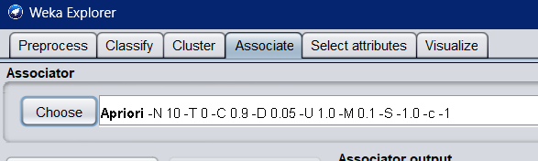

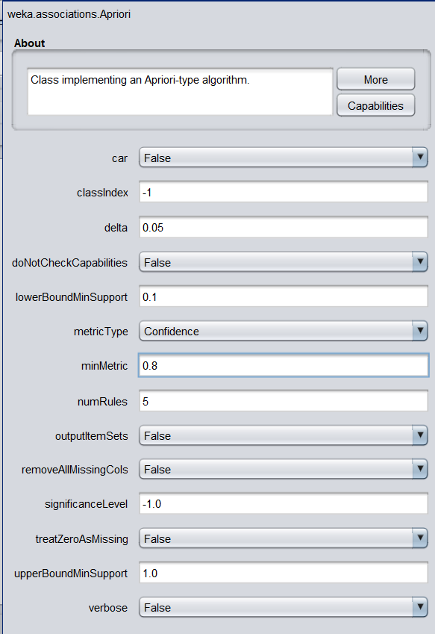

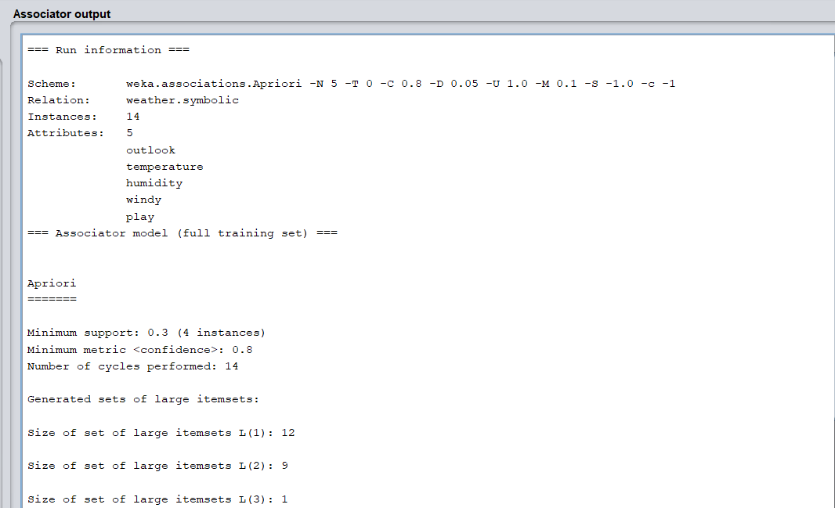

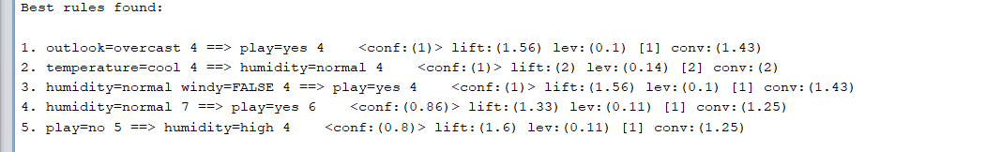

**Solution b:**

**Code:**

"""

Description : Simple Python implementation of the Apriori Algorithm

Usage:

$python apriori.py -f DATASET.csv -s minSupport -c minConfidence

$python apriori.py -f DATASET.csv -s 0.15 -c 0.6

"""

import sys

from itertools import chain, combinations

from collections import defaultdict

from optparse import OptionParser

def subsets(arr):

""" Returns non empty subsets of arr"""

return chain(*[combinations(arr, i + 1) for i, a in enumerate(arr)])

def returnItemsWithMinSupport(itemSet, transactionList, minSupport, freqSet):

"""calculates the support for items in the itemSet and returns a subset

of the itemSet each of whose elements satisfies the minimum support"""

_itemSet = set()

localSet = defaultdict(int)

for item in itemSet:

for transaction in transactionList:

if item.issubset(transaction):

freqSet[item] += 1

localSet[item] += 1

for item, count in localSet.items():

support = float(count) / len(transactionList)

if support >= minSupport:

_itemSet.add(item)

return _itemSet

def joinSet(itemSet, length):

"""Join a set with itself and returns the n-element itemsets"""

return set(

[i.union(j)

for i in itemSet for j in itemSet if len(i.union(j)) == length]

)

def getItemSetTransactionList(data_iterator):

transactionList = list()

itemSet = set()

for record in data_iterator:

transaction = frozenset(record)

transactionList.append(transaction)

for item in transaction:

itemSet.add(frozenset([item])) # Generate 1-itemSets

return itemSet, transactionList

def runApriori(data_iter, minSupport, minConfidence):

"""

run the apriori algorithm. data_iter is a record iterator

Return both:

- items (tuple, support)

- rules ((pretuple, posttuple), confidence)

"""

itemSet, transactionList = getItemSetTransactionList(data_iter)

freqSet = defaultdict(int)

largeSet = dict()

# Global dictionary which stores (key=n-itemSets,value=support)

# which satisfy minSupport

assocRules = dict()

# Dictionary which stores Association Rules

oneCSet = returnItemsWithMinSupport(

itemSet, transactionList, minSupport, freqSet)

currentLSet = oneCSet

k = 2

while currentLSet != set([]):

largeSet[k - 1] = currentLSet

currentLSet = joinSet(currentLSet, k)

currentCSet = returnItemsWithMinSupport(

currentLSet, transactionList, minSupport, freqSet

)

currentLSet = currentCSet

k = k + 1

def getSupport(item):

"""local function which Returns the support of an item"""

return float(freqSet[item]) / len(transactionList)

toRetItems = []

for key, value in largeSet.items():

toRetItems.extend([(tuple(item), getSupport(item)) for item in value])

toRetRules = []

for key, value in list(largeSet.items())[1:]:

for item in value:

_subsets = map(frozenset, [x for x in subsets(item)])

for element in _subsets:

remain = item.difference(element)

if len(remain) > 0:

confidence = getSupport(item) / getSupport(element)

if confidence >= minConfidence:

toRetRules.append(

((tuple(element), tuple(remain)), confidence))

return toRetItems, toRetRules

def printResults(items, rules):

"""prints the generated itemsets sorted by support and the confidence rules sorted by confidence"""

for item, support in sorted(items, key=lambda x: x[1], reverse=True):

print("item: %s , sup: %.3f" % (str(item), support))

print("\n------------------------ RULES:")

for rule, confidence in sorted(rules, key=lambda x: x[1], reverse=True):

pre, post = rule

print("Rule: %s ==> %s , conf: %.3f" % (str(pre), str(post), confidence))

def to_str_results(items, rules):

"""prints the generated itemsets sorted by support and the confidence rules sorted by confidence"""

i, r = [], []

for item, support in sorted(items, key=lambda x: x[1]):

x = "item: %s , %.3f" % (str(item), support)

i.append(x)

for rule, confidence in sorted(rules, key=lambda x: x[1]):

pre, post = rule

x = "Rule: %s ==> %s , %.3f" % (str(pre), str(post), confidence)

r.append(x)

return i, r

def dataFromFile(fname):

"""Function which reads from the file and yields a generator"""

with open(fname, "r") as file_iter:

for line in file_iter:

line = line.strip().rstrip(",") # Remove trailing comma

record = frozenset(line.split(","))

yield record

if __name__ == "__main__":

optparser = OptionParser()

optparser.add_option(

"-f", "--inputFile", dest="input", help="filename containing csv", default=None

)

optparser.add_option(

"-s",

"--minSupport",

dest="minS",

help="minimum support value",

default=0.15,

type="float",

)

optparser.add_option(

"-c",

"--minConfidence",

dest="minC",

help="minimum confidence value",

default=0.6,

type="float",

)

(options, args) = optparser.parse_args()

inFile = None

if options.input is None:

inFile = sys.stdin

elif options.input is not None:

inFile = dataFromFile(options.input)

else:

print("No dataset filename specified, system with exit\n")

sys.exit("System will exit")

minSupport = options.minS

minConfidence = options.minC

items, rules = runApriori(inFile, minSupport, minConfidence)

printResults(items, rules)

